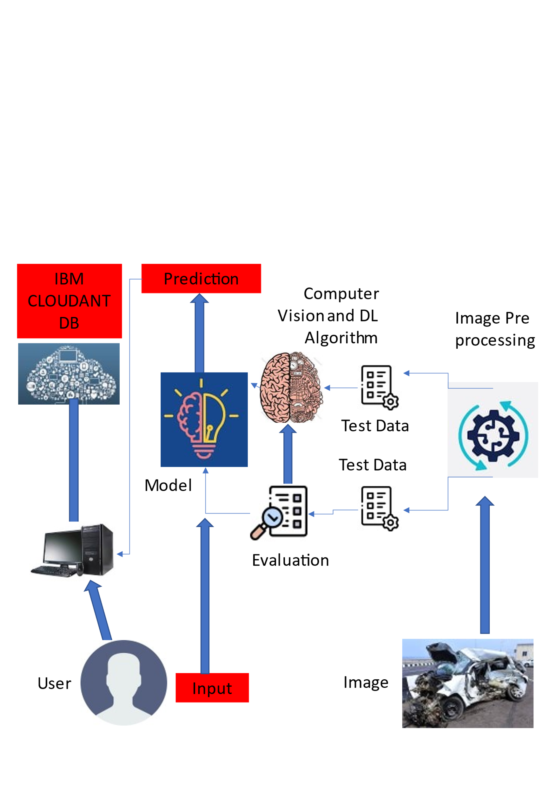**Project Design Phase-I**

**Solution Architecture**

|  |  |
| --- | --- |
| Date | 14 October 2022 |
| Team ID | PNT2022TMID47870 |
| Project Name | Intelligent Vehicle Damage Assessment & Cost Estimator for insurance Companies |
| Maximum Marks | 4 Marks |

